REALISTIC | How you see yourself | What you enjoy doing | Greatest skills align with
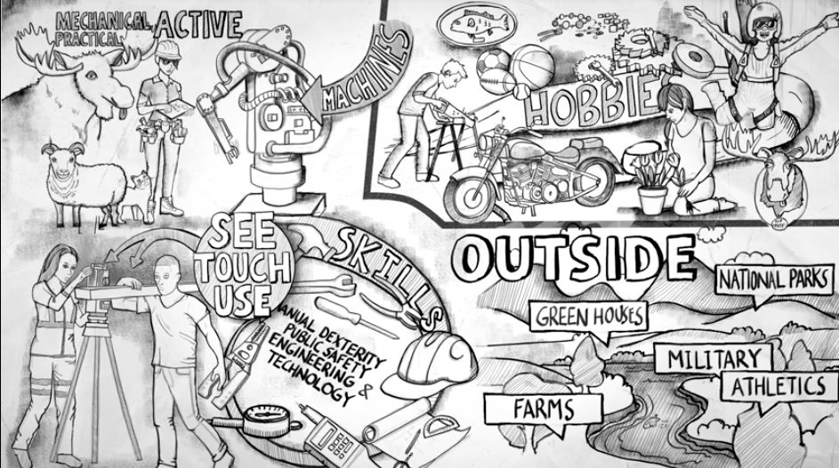 | Practical  Mechanical  Active | Hands-on activities  Working with animals  Working with tools  Working with machines  Gardening/landscaping  Hunting/fishing  Carpentry  Jewelry making  Playing sports  Driving vehicles | Building & repairing  Using tools & equipment  Concrete problem solving  Growing plants  Manual dexterity  Public safety  Engineering & technology
INVESTIGATIVE | How you see yourself | What you enjoy doing | Greatest skills align with
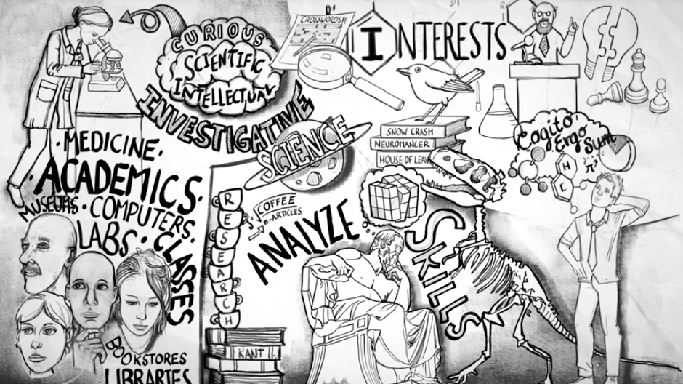 | Curious  Scientific  Intellectual | Gathering information  Analyzing & solving complex problems Math/science  Crosswords  Strategy games  Researching/Learning  Attending lectures  Conducting experiments  Discussing books  Birdwatching | Complex problem solving  Analyzing data  Natural & physical sciences  Thinking abstractly  Philosophy  Statistics  Researching

ARTISTIC | How you see yourself | What you enjoy doing | Greatest skills align with
 | Expressive  Original  Independent | Arts/Crafts  Drama/Dance/Music  Writing  Photography  Cooking  Hosting events  Making movies  Painting/drawing  Decorating  Learning languages  Traveling | Architecture  Musical ability  Foreign languages  Culture  Creativity  Communication  Media  Design
SOCIAL | How you see yourself | What you enjoy doing | Greatest skills align with
 | Helpful  Friendly  Trustworthy | Helping people  Reading about self-improvement  Volunteering  Being a mentor  Teaching  Social justice  Caring for children  Entertaining  Talking with friends  Listening/Giving advice | Listening  Psychology  Counseling  Spirituality  Human development  First aid  Social Sciences  Teaching/training  Building relationships

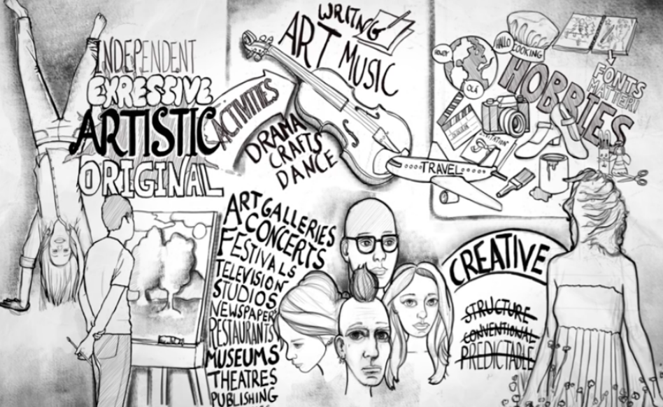
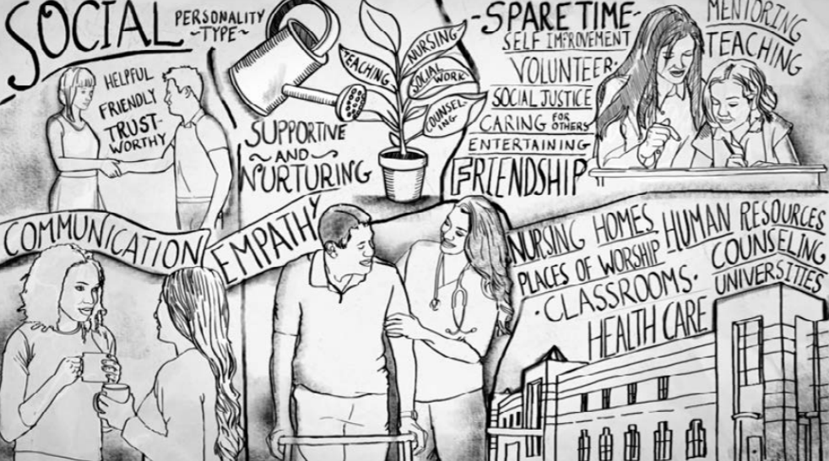

ENTERPRISING | How you see yourself | What you enjoy doing | Greatest skills align with
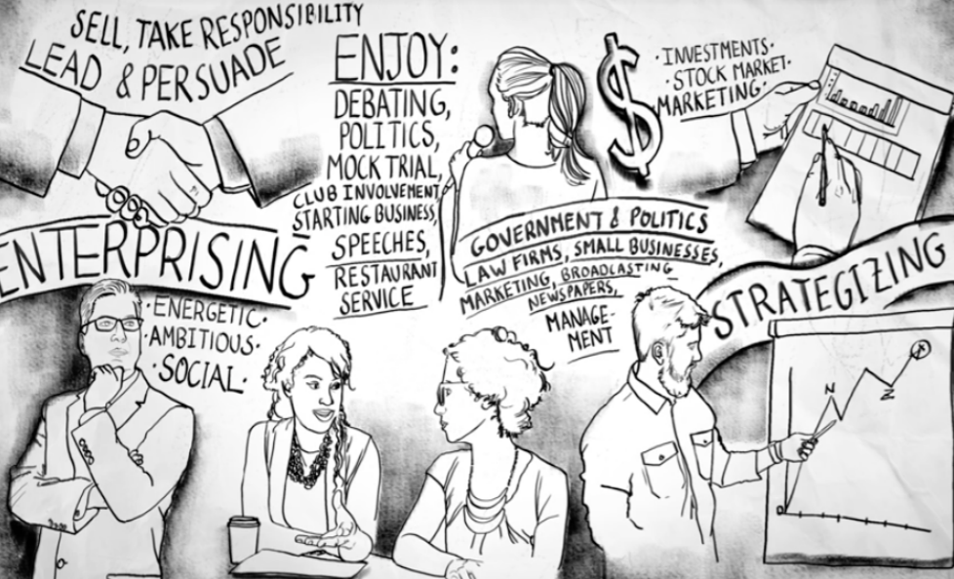 | Energetic  Ambitious  Sociable | Lead and persuade  Sell things  Take responsibility  Debating ideas  Political campaigns  Mock trial  Starting businesses  Making speeches  Serving at restaurants  Stock market  Developing ads | Public speaking  Negotiation  Supervising  Sales & marketing  Management  Leadership  Strategizing
CONVENTIONAL | How you see yourself | What you enjoy doing | Greatest skills align with
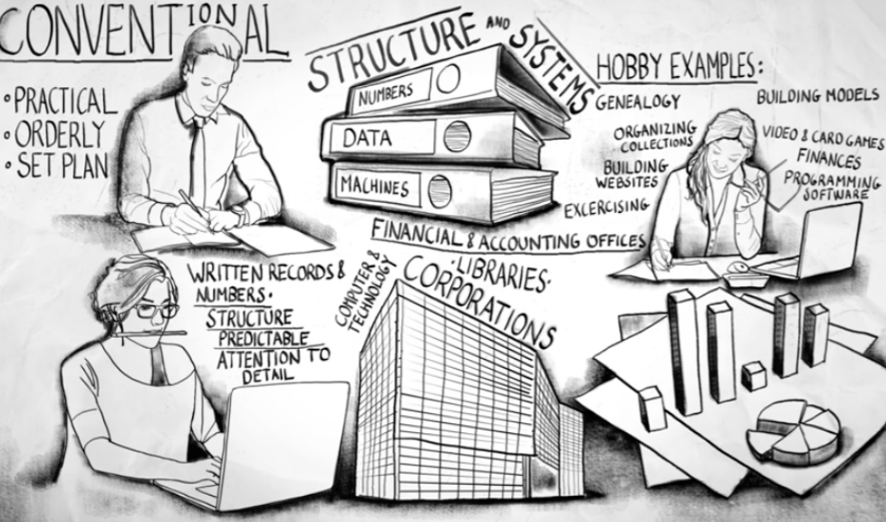 | Practical  Orderly  Good at following a set plan | Prefer structure/systems  Numbers & data  Machines  Charting family history  Building models  Computer/card games  Organizing collections  Building websites  Tracking finances  Exercising  Programming software | Organization  Mathematics  Accounting  Statistics  Computer programming  Economics  Charting trends  Finding patterns  Working with written numbers & records  Attention to detail

