The 3 Types of Resumes
Chronological  - Highlights the results and accomplishments in each job  - Staying in the same career or previous career | Functional  - Prioritizes key skills over career history  - Great for career changers, several jobs of short duration, multiple jobs with the same responsibility, or employment gaps | Combination  - Great for senior leadership roles  - Showcases key skills AND career history  - Longer format of 2-3 pages
The 4 Main Resume Sections
Header  - Your name  - Email  - Phone Number  - Position Title | Professional Summary  - Job Title  - Soft Skills  - Hard Skills  - Technology Skills | Work History  - Employer  - Location  - Job Title  - Start and end dates (month + year) | Education and Training  - High school or college degrees  - Certificates  - Training  - Licenses

Header Examples and Template
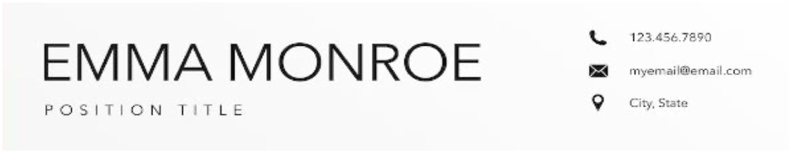 | 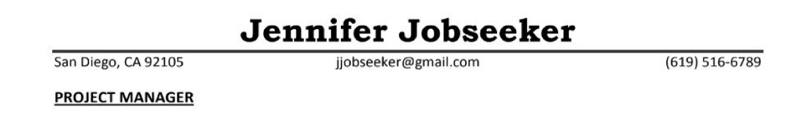
Fill in the box to the right with your header information. | Name:  Contact Information:  Job Title(s):

Skills
Hard skills – Describe what we do at work. You can search on O*Net Online (onetonline.org) to find a list that matches
your desired occupation.

Examples – typing, drawing blood, engineering, employee training, developing software

Soft skills – Describe how we do our work. Employers are willing to take a chance on candidates who demonstrate soft skills.

Examples – dependable, resourceful, creative & critical thinking, communication, collaboration, meeting deadlines, dedicated, flexible, hardworking, fast learner, reliable, innovative, passionate

Technology skills – Any technology that would be useful, applicable, and required for the job to which you are applying.

Examples – Microsoft Office, Google Suite, Zoom, data management software, CRM, LMS

Write the skills you wish to include in your professional summary in the space to the right.

Professional Summary Example and Template
Dedicated professional with extensive experience in customer service. Key skills include customer relation management software, problem solving, and quality assurance. Recognized for managing deadlines, employee training, conflict resolution and reliable service. Values open communication, teamwork and opportunities to grow.

Directions: Write your professional summary below. You can use the template or write your own. Remember, your professional summary should be 3-4 sentences in length and include a job title, 3-5 soft skills, 3-5 hard skills, and technology skills if you have them.

__________________ professional with __________ experience in ____________________. Key skills include _____________________, ____________________, and ____________________. Recognized for ____________________, ____________________, ____________________, and ____________________. Values____________________, ____________________, and opportunities to ____________________.

Work History/Experience Format
Chronological Resume:  Employer Location  Job Title Month/Year – Month/Year  3-6 Bullet points of skills that match the job description | Functional Resume:  Employer Job Title Month/Year – Month/Year  (Remember: This type of resume does not have bullet points underneath. You will list skills in another section instead.)
Skills Format
This format works for any type of resume. Use the following formula to help you write your bullet points of skills and achievements.

ACTION VERB + HOW + WHY
(What did you do?) (Add values/frequency/process) (Impact or results)

Some action verbs to use: plan, manage, organize, fundraise, participate, collaborate, utilize, conduct, mentor, communicate, assist, perform, lead, design, develop, invest

Example: Utilize strong customer service skills and passion for fashion to create a remarkable shopping experience for 150+ customers weekly.

Write some of your skills below:

Education, Training, Certificates, Professional Development, Licenses
This section can be titled anything that reflects your experience and comfort level. You can then include and highlight the opportunities you have taken advantage of. Below are some examples of how to title this section on a resume.

Education and Certification | Education and Training | Training and Professional Development | Licenses
Degree or certificate type, name of university or school, city, and state | Degree or training type, name of university or school, city, and state | Name of training or professional development session, name of institution, location | Name of license and issuing institution, date  *put “inactive” if expired
How will you title this section? What information will you include? Write it below.

Resources
- Brainfuse (brainfuse.com/jobnow/demopage.asp) – live resume coaching from 1 p.m. to 10 p.m. PST, resume templates, and more
- O*Net Online (onetonline.org) –learn what hard, soft, and technology skills are needed in different occupations as well as education level
- Jobscan (jobscan.co) – get 3 free resume scans to help you beat the ATS and align your skills to the job description
- San Diego Workforce Partnership (workforce.org/events) – take a free workshop, in-person or virtually, to help you with all things career navigation

