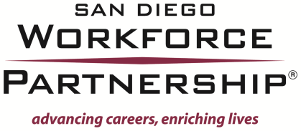

REQUEST FOR PROPOSALS
WIA YOUTH PILOT PROGRAM TO SERVE OUT-OF-SCHOOL YOUTH WITH DISABILITIES

CONFLICT OF INTEREST DISCLOSURE

- Please list any and all individuals who assisted, contributed and/or substantially influenced the writing, research, preparation and submission of this proposal:

- Are any of the individuals involved in the writing, preparation, research and/or submission of this proposal, members of any San Diego Workforce Partnership board and/or committee? If yes, please list those individuals:

- Were any of the individuals involved in the writing, preparation, research and/or submission of this proposal, employed by the San Diego Workforce Partnership within the last twelve (12) months? If yes, please list those individuals:

