Form 3
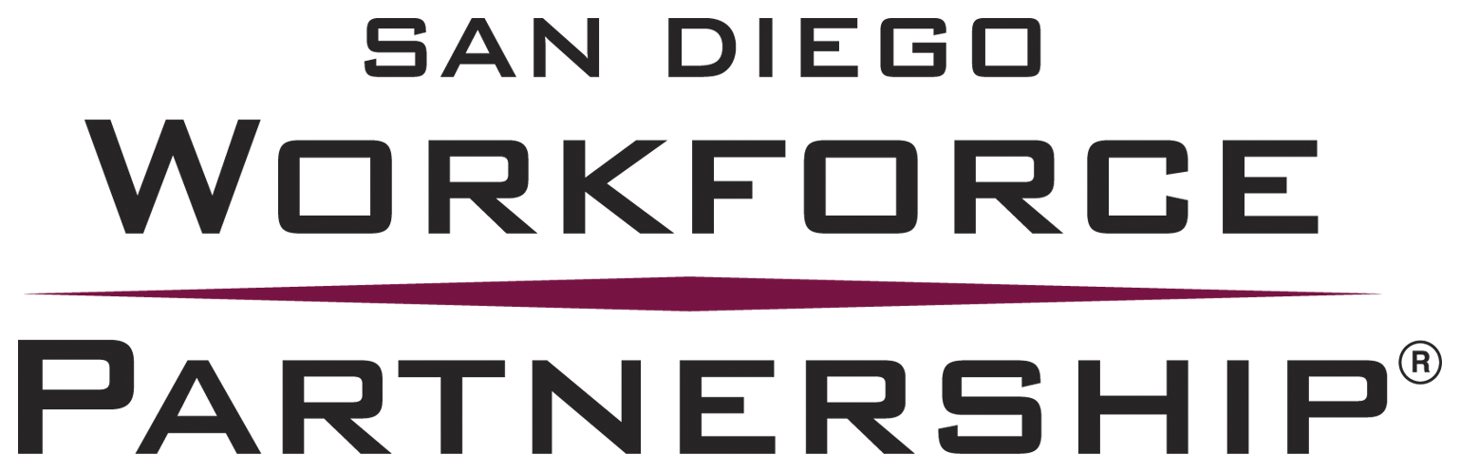
FINANCIAL MANAGEMENT STRUCTURE
FOR YOUTH CASE MANAGEMENT SERVICES

Instructions: Respondent is required to answer the following questions. This document should not exceed six pages.

Question 1
Provide an outline of your financial management structure, including the expertise of your staff to manage and account for governmentally funded programs.

Question 2
Briefly describe the method by which your accounting system segregates the funding received by your organization.

Question 3
Does your organization have an indirect cost agreement approved by a Federal or State cognizant agency?

If yes, the respondent is required to include a copy of the indirect cost agreement as an attachment to the proposed budget.

Question 4
Does your proposed budget include common costs allocable to multiple funding streams? If no, go to the question 5.

Does your organization have a written cost allocation plan?

Briefly describe the process for ensuring your organization’s compliance with its written cost allocation plan.

Question 5
Does your organization’s time sheet system allow for your employees to record their hours worked by funded activities, including recording time in and out for meals?

Briefly describe your organization’s time sheet system (personnel activity report) and the method by which employees are recording their time spent on more than one funded activities.

Question 6
Does your organization have written fiscal policies and procedures in place?

Briefly describe how your organization ensures that the duties of authorizing, recording, and maintaining custody of assets are segregated in practice.

Question 7
Briefly describe your organization’s experience with billing a funding agency using Microsoft Excel software for incurred costs recorded in the accounting system.

