FORM 1
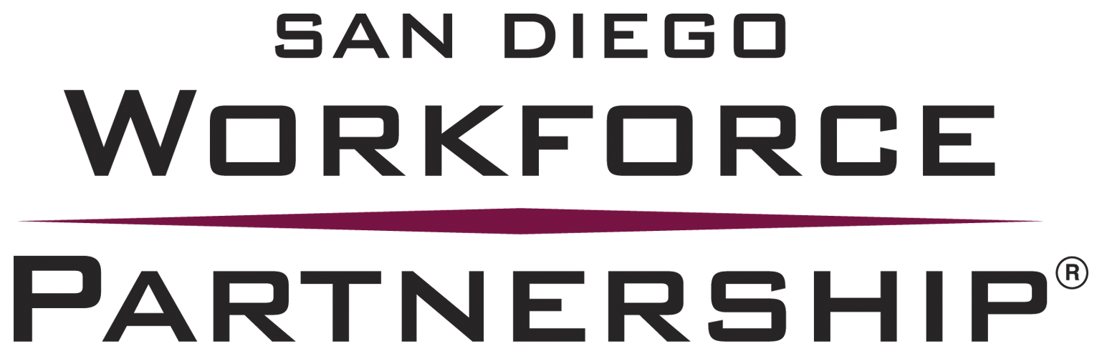

NOTICE OF INTENT TO SUBMIT A PROPOSAL
FOR YOUTH CASE MANAGEMENT SERVICES
All fields MUST be completed prior to submitting this form
All fields MUST be filled in prior to submitting this form

Name of Bidding Organization:

Address:

Contact Person/Title:

Telephone: Fax:

Email:

Our organization named above intends to submit a proposal for YOUTH CASE MANAGEMENT SERVICES.
Name |  |  |  |  | Title
Signature |  |  |  |  | Date

All Notices of Intent to Submit are due no later than 5:00 P.M. (PDT), Friday, June 6, 2014 to:
Diahna Leon, Youth Director
3910 University Ave., Suite #400
San Diego, CA 92105
619-228-2956
email: diahnaleon@workforce.org

