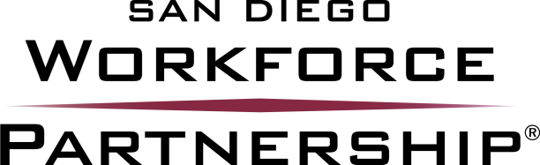

Notice of Intent to Submit a Proposal(s) for WIOA Youth Programs RFP

Please complete all fields prior to submitting this form
All fields MUST be filled in prior to submitting this form

Name of Bidding Organization:Click here to enter text.

Proposed Region(s): Click here to enter text.

Address: Click here to enter text.

Contact Person/Title: Click here to enter text.

Telephone: Click here to enter text. Fax: Click here to enter text.

Email: Click here to enter text.

Our organization named above intends to submit a proposal for WIOA YOUTH PROGRAMS.

Name: Click here to enter text. Title: Click here to enter text.

Signature:

All Notices of Intent to Submit are requested by 3:00 P.M. PST, Friday, January 22, 2016 to:
Email: YouthRFP@workforce.org

