**Regional Breakdown of Occupations and Industries**

Data for 2012-2017

EMSI, Second Quarter, 2011

Top Five Fastest Growing Occupations

|  |  |  |  |
| --- | --- | --- | --- |
| Metro | North | East | South |
| Business and financial operations occupations | Sales and related occupations | Business and financial operations occupations | Sales and related occupations |
| Sales and related occupations | Business and financial operations occupations | Construction and extraction occupations | Office and administrative support occupations |
| Office and administrative support occupations | Office and administrative support occupations | Sales and related occupations | Business and financial operations occupations |
| Management occupations | Management occupations | Office and administrative support occupations | Healthcare practitioners and technical occupations |
| Life, physical, and social science occupations | Healthcare practitioners and technical occupations | Healthcare practitioners and technical occupations | Management occupations |

Top Five Fastest Growing Industries

|  |  |  |  |
| --- | --- | --- | --- |
| Metro | North | East | South |
| Professional, Scientific, and Technical Services | Finance and Insurance | Construction | Government |
| Finance and Insurance | Professional, Scientific, and Technical Services | Health Care and Social Assistance | Health Care and Social Assistance |
| Health Care and Social Assistance | Health Care and Social Assistance | Finance and Insurance | Retail Trade |
| Real Estate and Rental and Leasing | Real Estate and Rental and Leasing | Professional, Scientific, and Technical Services | Professional, Scientific, and Technical Services |
| Administrative and Support and Waste Management and Remediation Services | Government | Government | Finance and Insurance |

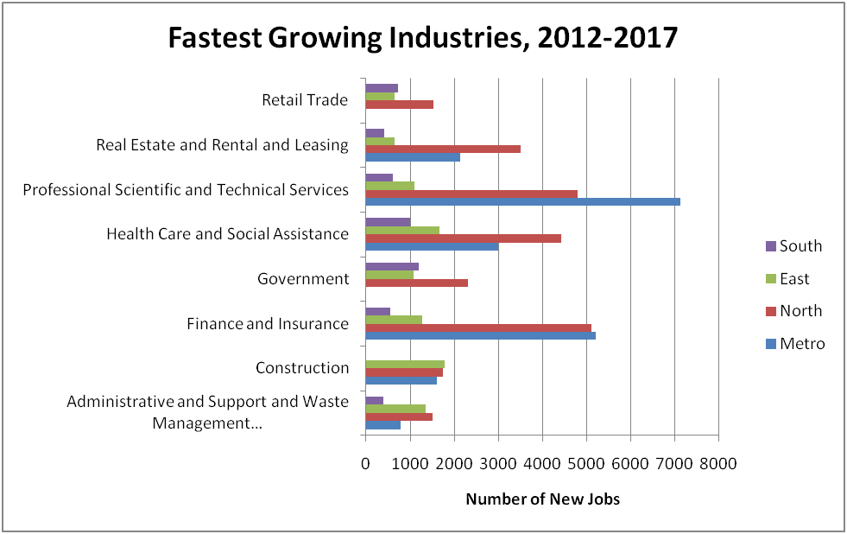

**Regional Breakdown of Occupations and Industries**

Data for 2012-2017

EMSI, Second Quarter, 2011

Metro Region

Largest 30 Industries



EPW = Average earnings per worker

Metro Region

30 Fastest Growing Industries



EPW = Average earnings per worker

Metro Region

30 Largest Occupations

***Education Level: Between Post-Secondary Credential and 2-Year Degree***



Metro Region

30 Fastest-Growing Occupations

***Education Level: Between Post-Secondary Credential and 2-Year Degree***



North County Region

30 Largest Industries



EPW = Average earnings per worker

North County Region

30 Fastest Growing Industries



EPW = Average earnings per worker

North County Region

30 Largest Occupations

***Education Level: Between Post-Secondary Credential and 2-Year Degree***



North County Region

30 Fastest Growing Occupations

***Education Level: Between Post-Secondary Credential and 2-Year Degree***



East County Region

30 Largest Industries



EPW = Average earnings per worker

East County Region

30 Fastest Growing Industries



EPW = Average earnings per worker

East County Region

30 Largest Occupations

***Education Level: Between Post-Secondary Credential and 2-Year Degree***



East County Region

30 Fastest Growing Occupations

***Education Level: Between Post-Secondary Credential and 2-Year Degree***



South County Region

30 Largest Industries



EPW = Average earnings per worker

South County Region

30 Fastest Growing Industries



EPW = Average earnings per worker

East County Region

30 Largest Occupations

***Education Level: Between Post-Secondary Credential and 2-Year Degree***



East County Region

30 Fastest Growing Occupations

***Education Level: Between Post-Secondary Credential and 2-Year Degree***

