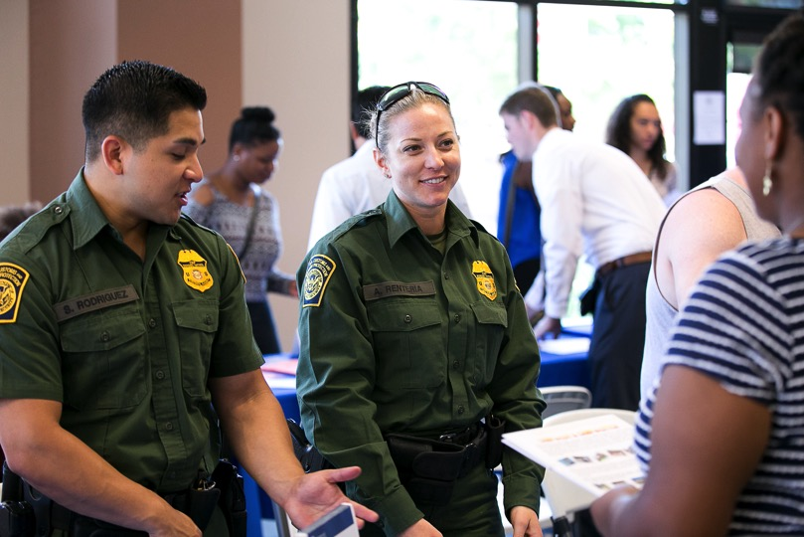

***COMPANY EVENT   
NAME HERE***

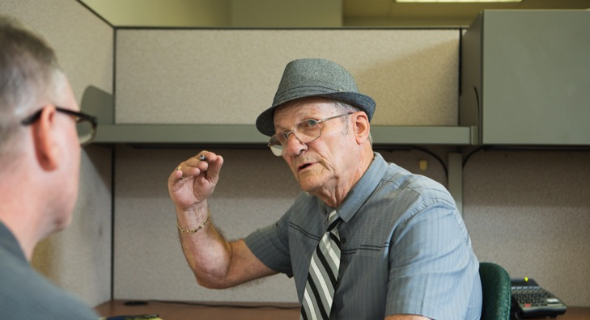





*For more information, contact First Last at (XXX) XXX-XXXX or email@company.org*

SDWP provides equal opportunity for its programs, services and employment. Auxiliary aids and services for individuals with disabilities are available upon request.

***DATE:***   
Tuesday, December 15, 2015  
  
***TIME:***   
10 a.m. – 11 a.m.

***LOCATION:***   
South Metro Career, 4389   
Imperial Ave.,   
San Diego 92113

Insert event description here. Young adults ages 16-24 are invited to attend this event.   
Some company will be on site to share job information, collect applications and interview prospective employees.

*Come prepared with printed copies of   
your résumé.*