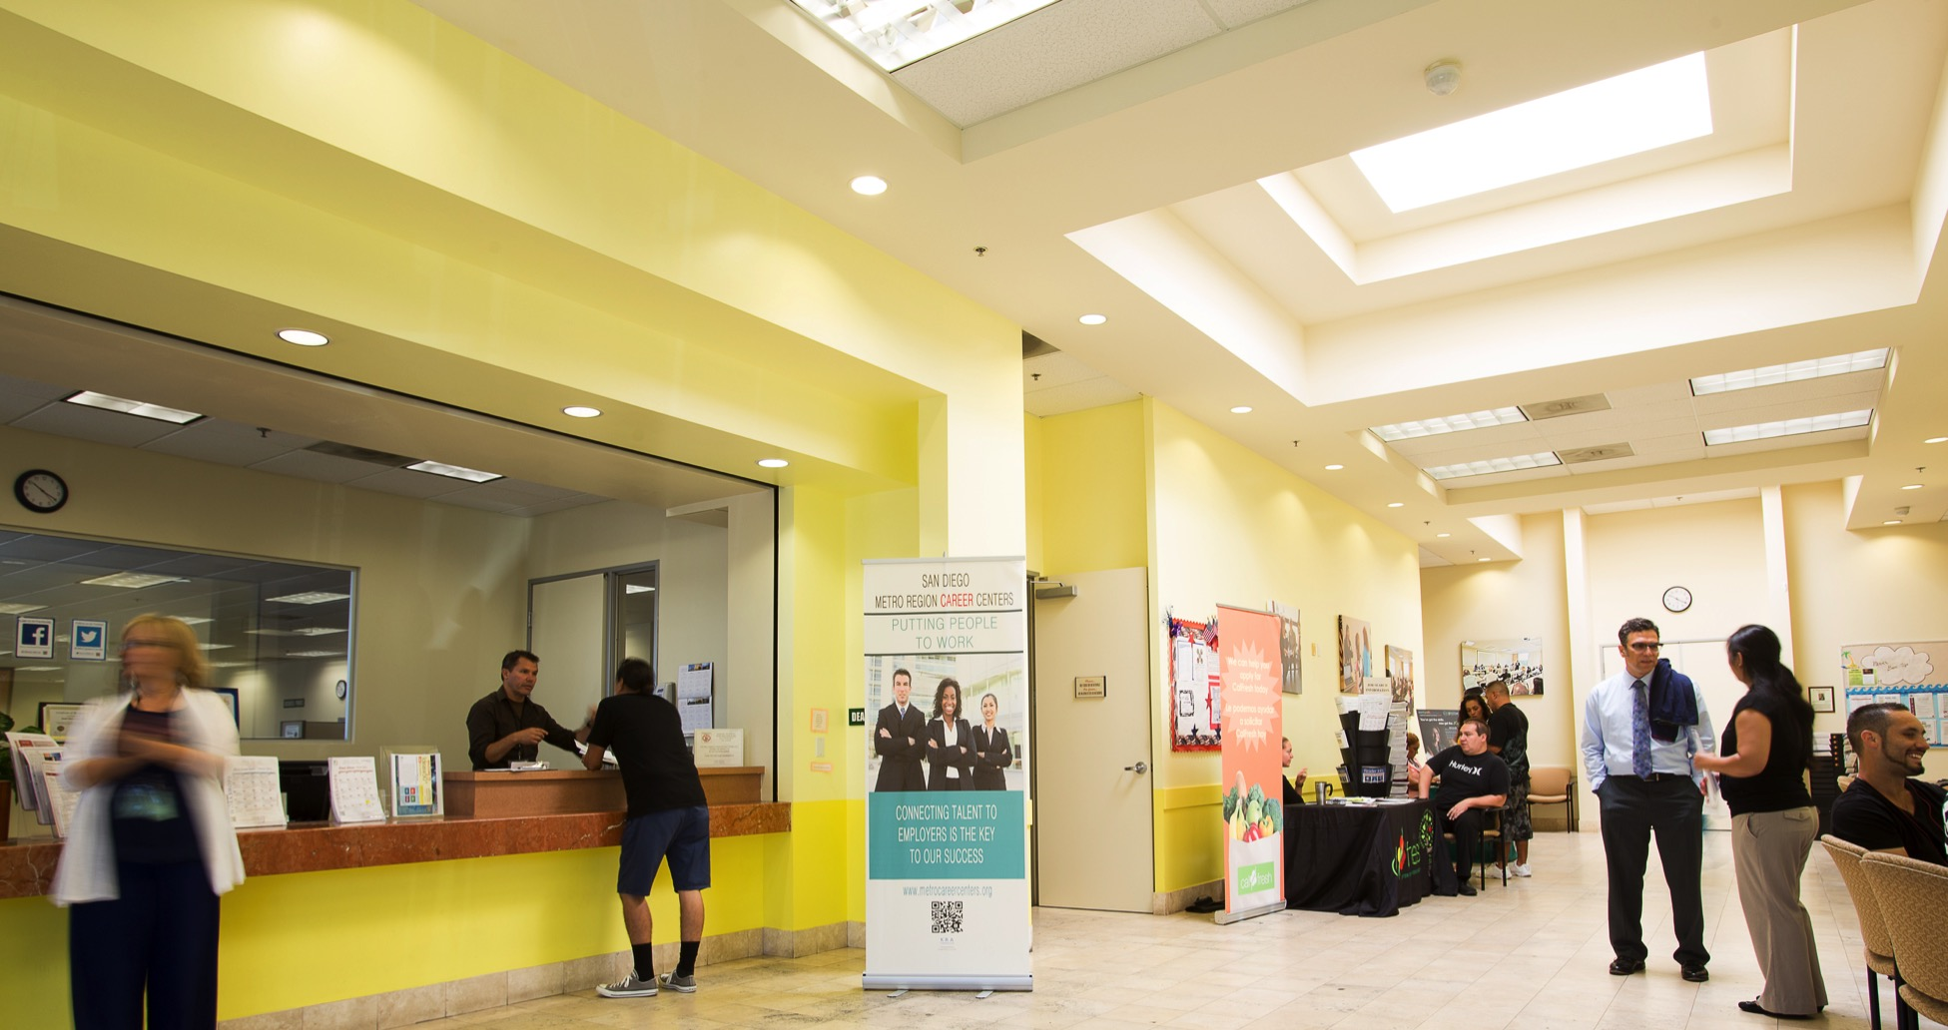

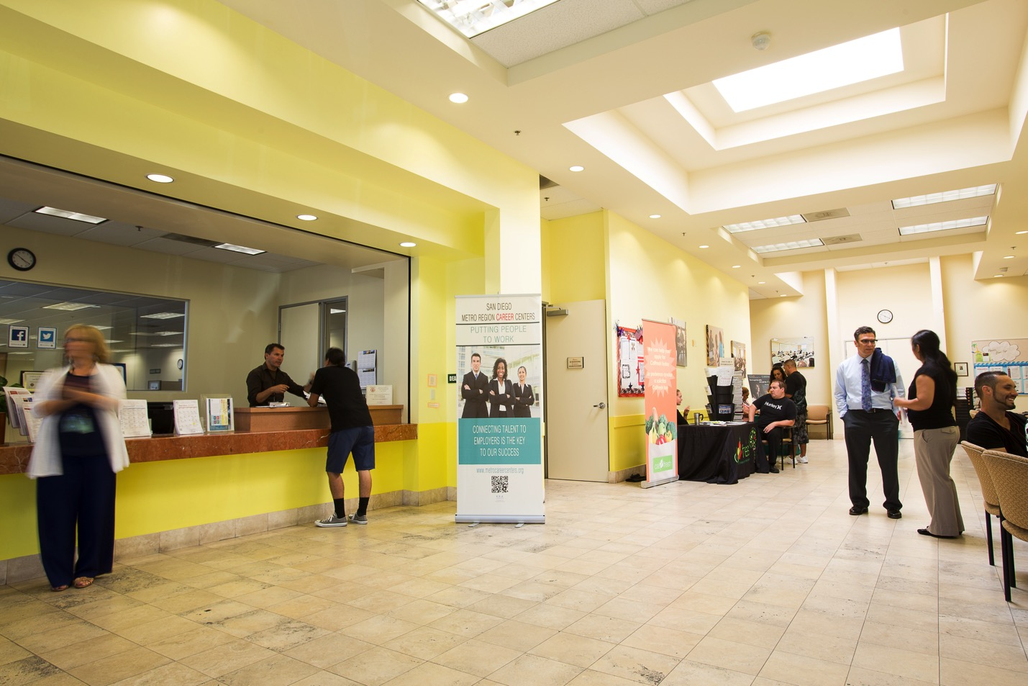w

**INSERT   
COMPANY**

**EVENT   
NAME HERE**

SDWP provides equal opportunity for its programs, services and employment. Auxiliary aids and services for individuals with disabilities are available upon request.



**DATE:**

Tuesday, December 15, 2015  
  
**TIME:**   
10 a.m. – 11 a.m.  
  
**LOCATION:**

South Metro Career,

4389 Imperial Ave.,

San Diego 92113

Insert event description here. Young adults ages 16-24 are invited to attend this event. Some company will be on site to share job information, collect applications and interview prospective employees.

*Come prepared with printed   
copies of your resume*

For more information, contact First Last at (XXX) XXX-XXXX or email@company.org