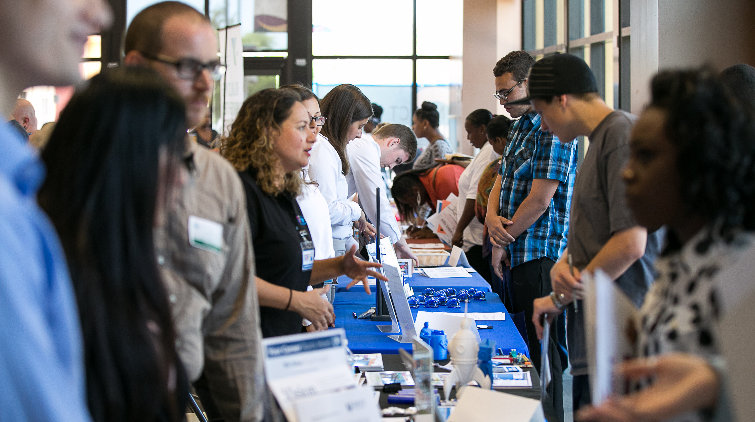

SDWP provides equal opportunity for its programs, services and employment. Auxiliary aids and services for individuals with disabilities are available upon request.



For more information, contact First Last at (XXX) XXX-XXXX or email@company.org

COMPANY EVENT NAMEEVENT NAME

DATE: Tuesday, December 15, 2015

TIME: 10 a.m. – 11 a.m.

LOCATION: South Metro Career, 4389 Imperial Ave.,   
San Diego 92113

Insert event description here. Young adults ages 16-24 are invited   
to attend this event. Some company will be on site to share job information,   
collect applications and interview prospective employees.

*Come prepared with printed copies of your résumé.*