Attachment A
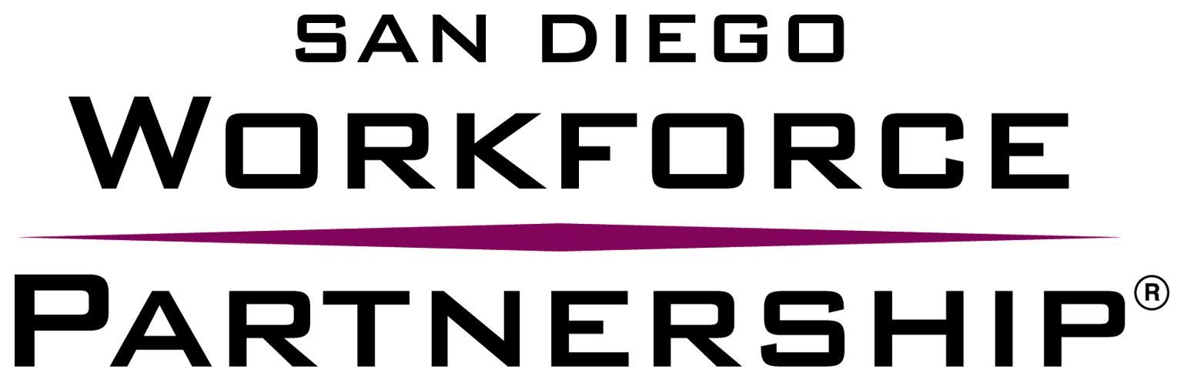

CONFLICT OF INTEREST DISCLOSURE FORM
FOR ACT NATIONAL CAREER READINESS CERTIFICATE (NCRC) CONSULTANT

NAME OF ORGANIZATION: ____________

- Please list any and all individuals who assisted, contributed and/or substantially influenced the writing, research, preparation and submission of this quote:

- Are any of the individuals involved in the writing, preparation, research and/or submission of this quote, members of Workforce Development Board, San Diego Consortium Policy Board, Adult Programs Committee, Youth Council and SDWP staff? If yes, please list those individuals:

- Were any of the individuals involved in the writing, preparation, research and/or submission of this quote, employed by SDWP within the last twelve (12) months? If yes, please list those individuals:

- If applicable, please describe any additional Conflict of Interest disclosures below.

I certify that the organization listed above has no conflict of interest as stated in the Request for Quotes.

Name:

Signature: _______________________________ Date: ______________________________

