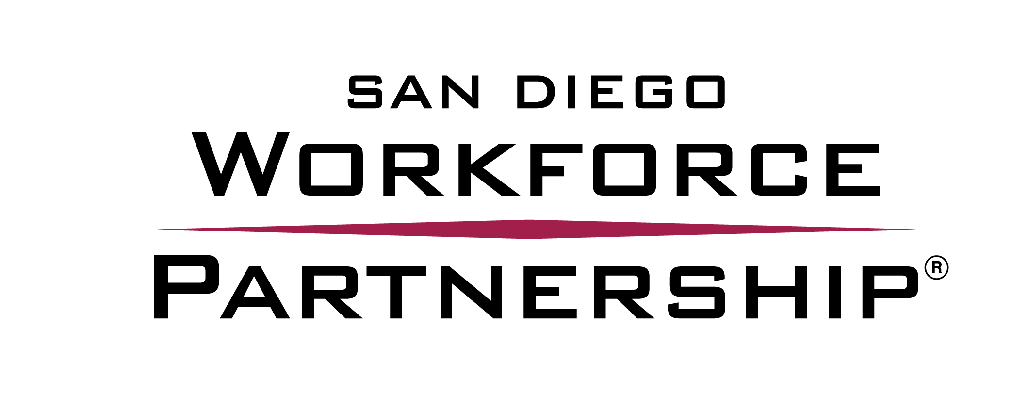 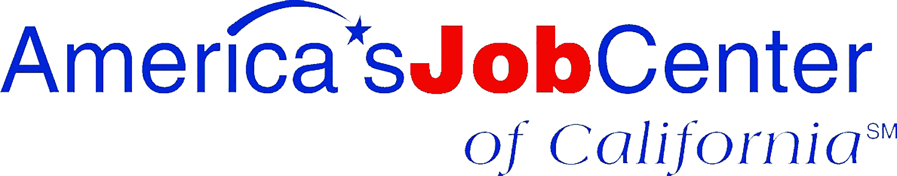 WORKSHOPS AND ACTIVITIES – MONTH YYYY
MONDAY | TUESDAY | WEDNESDAY | THURSDAY | FRIDAY
1
Event Name: 9–10:30 A.M.
Event Name: X:XX–X:XX
Event Name: X:XX–X:XX
Event Name: X:XX – X:XX
4  Event Name  X:XX–X:XX  Event Name  X:XX–X:XX | 5  Event Name  X:XX–X:XX  Event Name  X:XX–X:XX | 6  Event Name  X:XX–X:XX  Event Name  X:XX–X:XX | 7  Event Name  X:XX–X:XX  Event Name  X:XX–X:XX | 8  Event Name  X:XX–X:XX  Event Name  X:XX–X:XX
11  Event Name  X:XX–X:XX  Event Name  X:XX–X:XX | 12  Event Name  X:XX–X:XX  Event Name  X:XX–X:XX | 13  Event Name  X:XX–X:XX  Event Name  X:XX–X:XX | 14  Event Name  X:XX–X:XX  Event Name  X:XX–X:XX | 15  Event Name  X:XX–X:XX  Event Name  X:XX–X:XX
18  Event Name  X:XX–X:XX  Event Name  X:XX–X:XX | 19  Event Name  X:XX–X:XX  Event Name  X:XX–X:XX | 20  Event Name  X:XX–X:XX  Event Name  X:XX–X:XX | 21  Event Name  X:XX–X:XX  Event Name  X:XX–X:XX | 22  Event Name  X:XX–X:XX  Event Name  X:XX–X:XX
25  Event Name  X:XX–X:XX  Event Name  X:XX–X:XX | 26  Event Name  X:XX–X:XX  Event Name  X:XX–X:XX | 27  Event Name  X:XX–X:XX  Event Name  X:XX–X:XX | 28  Event Name  X:XX–X:XX  Event Name  X:XX–X:XX | 29  Event Name  X:XX–X:XX  Event Name  X:XX–X:XX

SDWP provides equal opportunity for its programs, services and employment. Auxiliary aids and services for individuals with disabilities are available upon request.

WORKSHOP DESCRIPTIONS

Building a Résumé
A great résumé is the key to landing job interviews. Participants will learn what it takes to build résumés employers will love. They will learn how to share about previous jobs, volunteer positions and other experience, then create a résumé using our mobile résumé lab. The mobile résumé lab can serve up to 10 participants at once; training sites that also have access to a computer lab are preferred.

Creating an Elevator Pitch
Elevator pitches are brief, rehearsed introductions that give potential employers a “highlight reel” of a person’s experiences and aspirations — answering the common “tell me about yourself” interview question. Participants will build a pitch that includes their passions, goals and qualifications, then practice their pitch individually and in groups.

Preparing for Interviews
A strong interview can mean the difference between “you’re hired” and “don’t call us; we’ll call you.” At this workshop, participants will learn strategies for interview success and engage in practice interviews with their peers.

In-Demand Jobs
San Diego’s economy offers many engaging, fulfilling work opportunities many young people may not even know exist. During this workshop, we’ll share about San Diego’s fastest-growing industries and occupations and help participants learn what they can do now to qualify for those job opportunities in the future.

CONNECT2Careers Registration Drive
The CONNECT2Careers portal gives youth access to job postings, a peer job coach and resources like résumé templates and practice interview questions. We’ll bring our mobile application lab (serves up to 10 participants at a time) to accept online registrations and answer questions youth may have as they register for the portal.

Building a Résumé
A great résumé is the key to landing job interviews. Participants will learn what it takes to build résumés employers will love. They will learn how to share about previous jobs, volunteer positions and other experience, then create a résumé using our mobile résumé lab. The mobile résumé lab can serve up to 10 participants at once; training sites that also have access to a computer lab are preferred.

Creating an Elevator Pitch
Elevator pitches are brief, rehearsed introductions that give potential employers a “highlight reel” of a person’s experiences and aspirations — answering the common “tell me about yourself” interview question. Participants will build a pitch that includes their passions, goals and qualifications, then practice their pitch individually and in groups.

Preparing for Interviews
A strong interview can mean the difference between “you’re hired” and “don’t call us; we’ll call you.” At this workshop, participants will learn strategies for interview success and engage in practice interviews with their peers.

