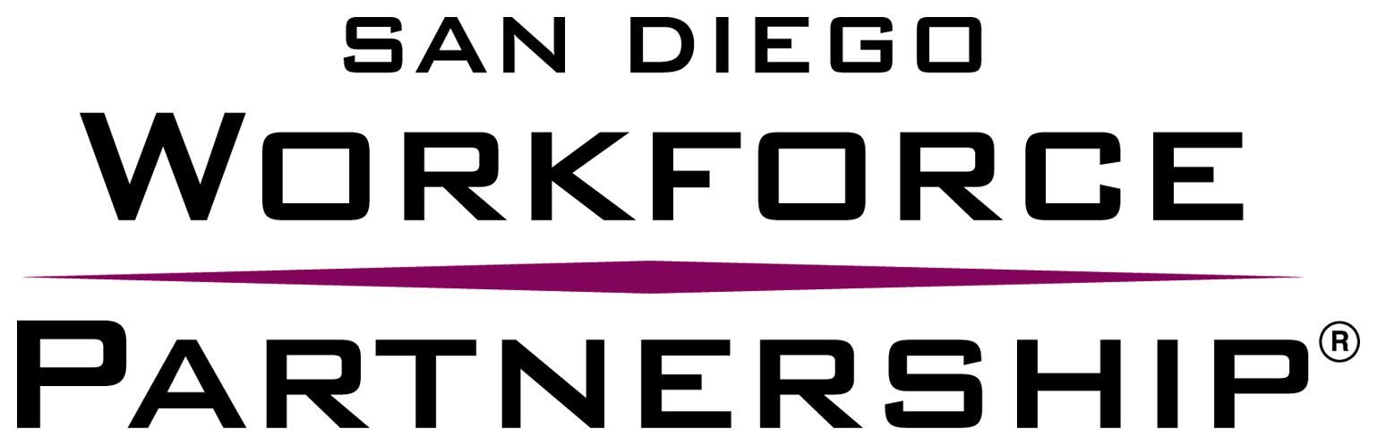

Conflict of Interest Disclosure for WIOA Youth Programs RFP

NAME OF ORGANIZATION: Click here to enter text.

- Please list any and all individuals who assisted, contributed and/or substantially influenced the writing, research, preparation and submission of this proposal:
Click here to enter text.

- Are any of the individuals involved in the writing, preparation, research and/or submission of this proposal, members of the Workforce Development Board, San Diego Consortium Policy Board, Adult Programs Committee, Youth Council and SDWP staff? If yes, please list those individuals:
Click here to enter text.

- Were any of the individuals involved in the writing, preparation, research and/or submission of this proposal, employed by SDWP within the last twelve (12) months? If yes, please list those individuals:
Click here to enter text.

- If applicable, please describe any additional Conflict of Interest disclosures below.
Click here to enter text.

I certify that the organization listed above has no conflict of interest as stated in the RFP.

Name:

Signature: _______________________________ Date: ______________________________

