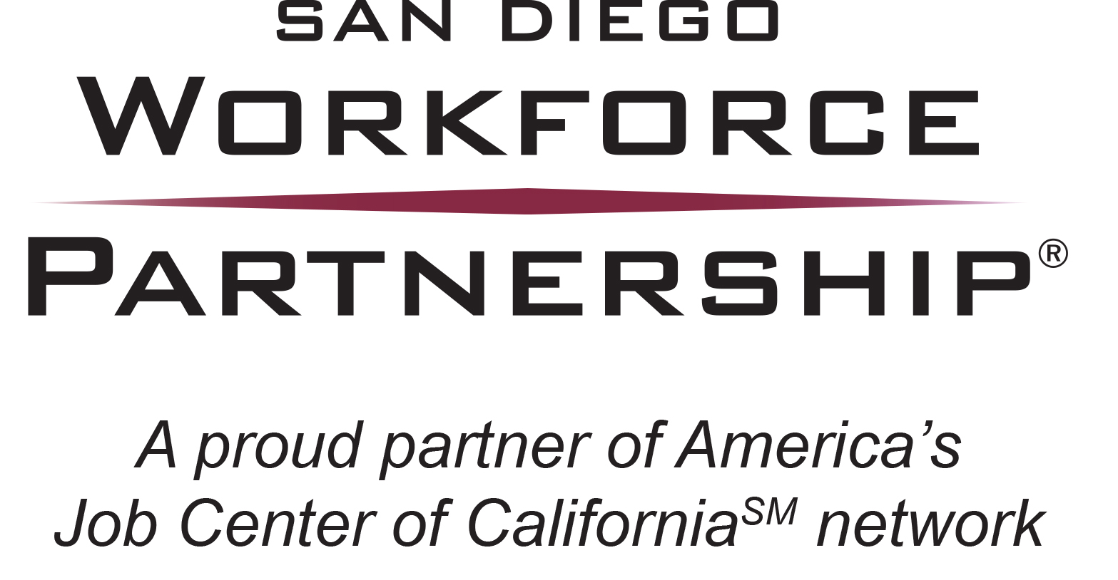

GLOSSARY OF TERMS

LEGISLATIVE/GOVERNMENT

San Diego Consortium Policy Board (Policy Board) –A five-member board made up of two San Diego City Council members, two San Diego County Supervisors, and one business representative appointed by the United Way. The Policy Board serves as the local elected official required under WIA, and oversees funding and policy development under the WIA. The Policy Board appoints the members of the WIB.

United States Department of Labor (DOL) –The administrative department at the federal level responsible for the administration of WIA.

Workforce Investment Act (WIA) – The federal law that governs the public workforce development system in the United States. President Clinton signed WIA into law on August 7, 1998. WIA reformed federal job training programs and created a comprehensive workforce system. The system is intended to be customer-focused, providing individuals, including youth, access to the tools needed for managing their careers and helping businesses find skilled workers.

Workforce Investment Board (WIB) –A governing board, required under WIA legislation, made up of mandatory WIA partners, non-mandatory partners, and businesses. In San Diego County, the WIB is a 49-member board.

Workforce Innovation and Opportunity Act (WIOA) – The federal law that will govern the public workforce development system in the United States, effective July 1, 2015. President Obama signed WIOA into law on July 22, 2014. WIOA is designed to help job seekers access employment, education, training, and support services to succeed in the labor market and to match employers with the skilled workers they need to compete in the global economy. Congress passed the Act by a wide bipartisan majority; it is the first legislative reform in 15 years of the public workforce system.

WORKFORCE TERMS

Assessment – Assessment includes a review of educational skill levels, occupational skills, prior work experience, employability, interests, aptitudes (including interest in non- traditional jobs), and supportive service needs. Where appropriate, recent assessments (within 6 months) could be used in lieu of additional assessment. The goal is to accurately evaluate the youth in order to develop an appropriate service strategy to meet his/her individual needs.

Barriers to Employment - Any demonstrable characteristic(s) of an applicant that has served to limit, hinder or prohibit that person’s opportunities for employment and/or promotion. Examples of barriers to employment for youth are: limited English language proficiency, teenage parenting, individuals with disabilities, substance abuse, homelessness, basic skills deficiency, and welfare assisted youth.

Basic Skills Deficient – English reading, writing, or computing skills at or below the 8th grade level (8.9) on a generally accepted standardized test or a comparable score on a criterion referenced test, or an inability to compute or solve problems, read, write, or speak English at a level necessary to function on the job, in the family, or in society.

Case Management – A client-centered approach in the delivery of all encompassing, customized services. This is an activity used to document the general coordination of all other client services.

Collaborative – A mutually beneficial and well-defined relationship entered into by organizations to achieve common goals. The relationship includes a jointly developed structure and responsibility, mutual authority, and accountability for success and sharing of resources.

Credential – A nationally recognized degree or certificate or a state/locally recognized credential. Credentials include, but are not limited to a high school diploma, GED, or other recognized equivalents, postsecondary degrees/certificates, recognized skills standards and licensure or industry-recognized certificates. Includes all State Education Agency recognized credentials.

Exit/Closure – The time at which a client completes services, or the quarter within which he has not received any WIA services for 90 days, except follow-up, and has no future services scheduled. A closure will need to be created in CalJOBS.

Participant – An individual who has been determined to be eligible to participate in and who is receiving services (except follow-up services authorized under WIA) under a program authorized by WIA, Title I. Participation shall be deemed to commence on the first day, following determination of eligibility, on which the individual began receiving staff assisted services.

Registration/Participation – All clients eligible for WIA services must be registered/create participation in CalJOBS in order to receive services. At the point of registration, clients are counted for performance measurement purposes.

Supportive Services – Such services as transportation, child care, housing/shelter, clothing/uniforms, work related tools, license/certification fees, corrective lenses, or food that are necessary to enable an individual to participate in activities authorized under Title 1 of WIA and are consistent with the provisions of the Act.

Unsubsidized Employment – Full or part-time permanent employment not financed with state or federal funds. Includes entry into the Armed Forces, entry into employment in a registered apprenticeship program, and self-employment.

Work Readiness Skills –Pre-employment skills (e.g. resumes, applications, and interviews), work maturity skills (e.g. problem solving, teamwork, and organization skills), employability skills (e.g. punctuality, dependability, and appearance), basic skills (reading, writing, and math), and generic occupational skills (e.g. customer service and safety procedures).

Workforce Development –Services that help individuals find employment and receive training that leads to job placement and career advancement, while simultaneously helping businesses meet their needs for qualified personnel. The services overseen by the WIB and delivered via the AJCC Network are workforce development services.

PROCUREMENT TERMS

Request for Proposals (RFP) – A solicitation for proposals for the purchase of products or services.

Statement of Qualifications (SOQ) – An application SDWP uses to determine an organization’s administrative and fiscal capacity to meet SDWP, state, and federal government requirements for the provision of WIA services.

OTHER

In-kind Contribution – Contributions of equipment, supplies, or other tangible resources, as distinguished from a cash contribution or monetary grant. Some businesses, individuals, or non-profit organizations may also donate the use of space or staff time as an in-kind contribution. In-kind contributions are assessed at their current fair value, not the new retail value of the items in question.

Recidivism – Recidivism is one of the most fundamental concepts in criminal justice. It refers to a person's relapse into criminal behavior, often after the person receives sanctions or undergoes intervention for a previous crime. Criminal acts that resulted in rearrests, reconviction or return to prison with or without a new sentence during a three-year period following the prisoner’s release, measures recidivism. Retrieved from

http://www.nij.gov/topics/corrections/recidivism/pages/welcome.aspx

Justice Involved Individuals – Are defined as anyone who has experienced the Criminal Justice System.

